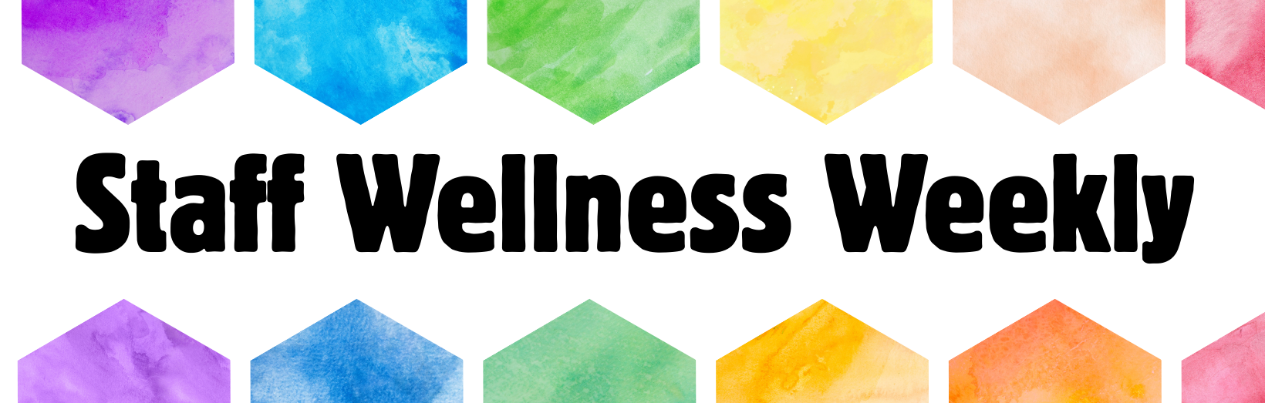
Recent Happenings
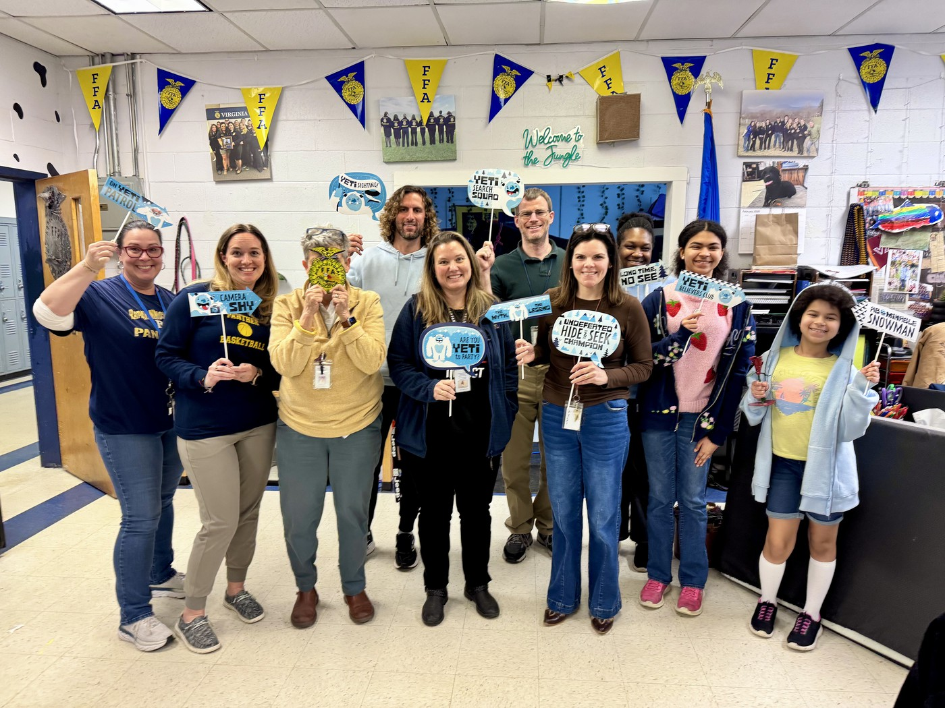
The Yeti-themed BINGO was a wild, good time! Thank you to everyone who joined the fun as we said farewell to winter! We want to thank Laura Szupinka for donating all the Yeti decorations and BINGO cards, and Michele Fincham for sharing her classroom and contributing to our prizes.

Upcoming Staff Events
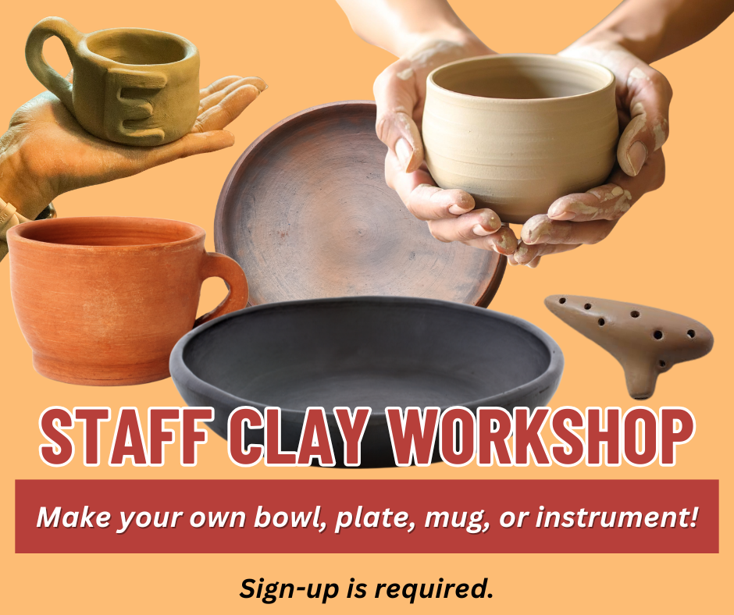
Staff Clay Workshop Series kicks off on March 3rd! Join us for an open studio format with demonstrations starting at 3:40 pm each of the following Tuesdays.
- March 3rd- Bowls, pinch pots, and plate forms
- March 10th- Mugs and attach whistle and finger holes to forms for ocarinas
- March 17th- Underglazes for sgraffitto work
High Fire glazing will be done on April 14th and work will be available for pick up the following week.
To sign-up, visit (insert link)
Special thanks to Rebecca Flowers for hosting this fantastic pottery workshop series!!

Staff Shout-outs
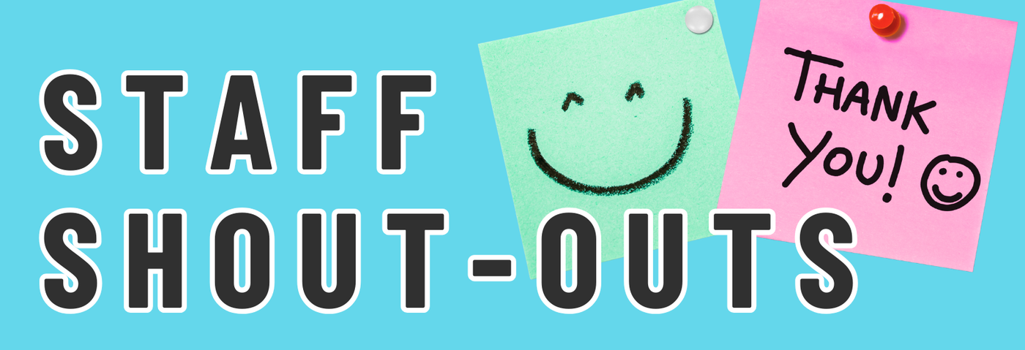

Let's spread thankfulness, positivity, and good vibes! Each week, we will share shout-outs from staff, for staff. Whether you want to share a thank you or a kind note, let other staff members know how much they are valued and appreciated. Shout-outs can be anonymous. Check back next week to see all the kind notes we have collected.
To submit staff shout-outs, visit (insert google link)

Check last week’s staff shout-outs below.
- Thank you to Jeff Day and Kreighton Long. Your Inspired Teaching lessons on Friday were engaging, fun, and meaningful to daily teaching life. I appreciate you both taking the time to plan such useful strategies!
- Jenny Kapsa for all her hard work in preparing our seniors for after graduation with countless resume and interview workshops and recruiting community members to give our students these experiences before they enter the real world! You are amazing and your dedication to our students is incredible!
- Hogan -- thanks for being such a big supporter of the RCHS library programs and for recruiting teacher participants to make buttons during Parent-Teacher Conferences. I appreciate your support and advocacy! -Katie
- Thank you Sallie for being a constant supporter of the teachers and classrooms at both schools! You are an amazing mentor and sudo-Admin!
- Meg Flanagan you are crushing it as a teacher and Quiz Bowl coach! Your students love you and you are such an amazing asset to our school!

Reminders

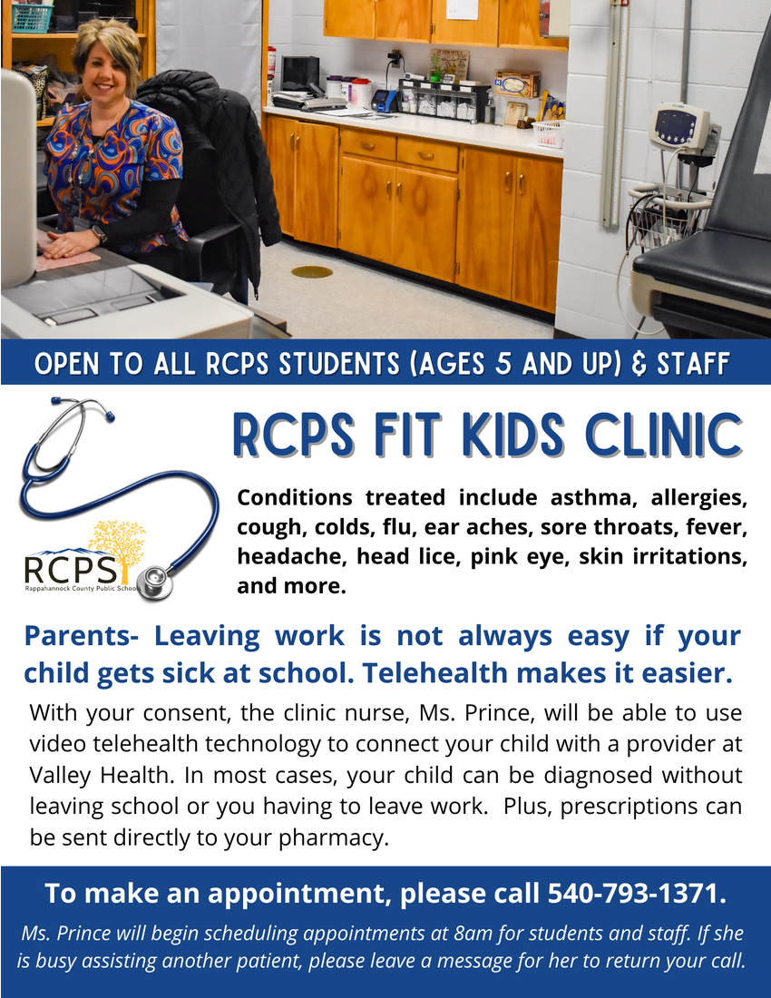
As a friendly reminder, our Fit Kids Clinic is open to ALL RCPS students (ages 5 and up) and staff. This is a fantastic resource to be quickly seen without leaving the campus. To make an appointment with Tara Prince, our amazing telehealth nurse, call 540-793-1371.
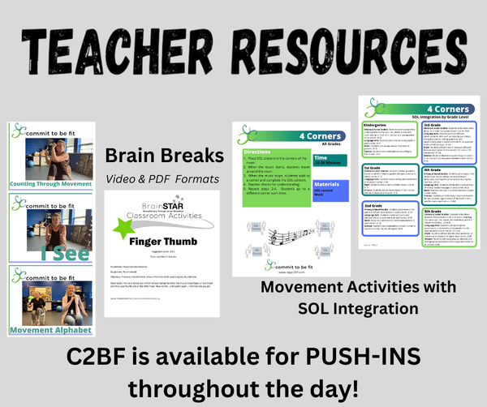
As a friendly reminder, we have a massive database of brain boosters (PreK-12) and movement games/activities with SOL and content integration ideas (PK-5). To view, visit the Teacher Resource page. If you prefer, the C2BF team would be happy to come to your classroom and lead a brain break, activity, or even a mindful minute. Email us to schedule a push-in.

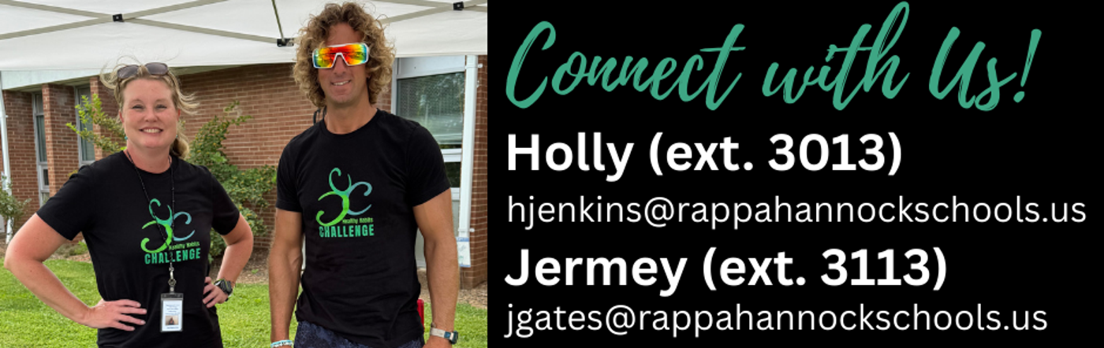
Holly and Jermey are available for classroom push-ins! Whether you would like for us to lead a short brain booster followed by a mindful minute OR would like for us to lead active lessons, reach out today!

ABOUT COMMIT TO BE FIT: Commit to Be Fit is a school sponsored, grant funded program in Rappahannock County, Virginia. Through the generosity of the PATH Foundation, Commit to Be Fit was created to promote a culture of wellness in Rappahannock County Public Schools and the Rappahannock community.

